**Azure Data Factory**

*Task – When an excel file is uploaded in a VM folder, automatically column A is copied to column 3, and the file is uploaded in the storage account blob folder using ADF*

1. Create an ADF, VM (make sure accelerated networking is off) and a storage account.
2. 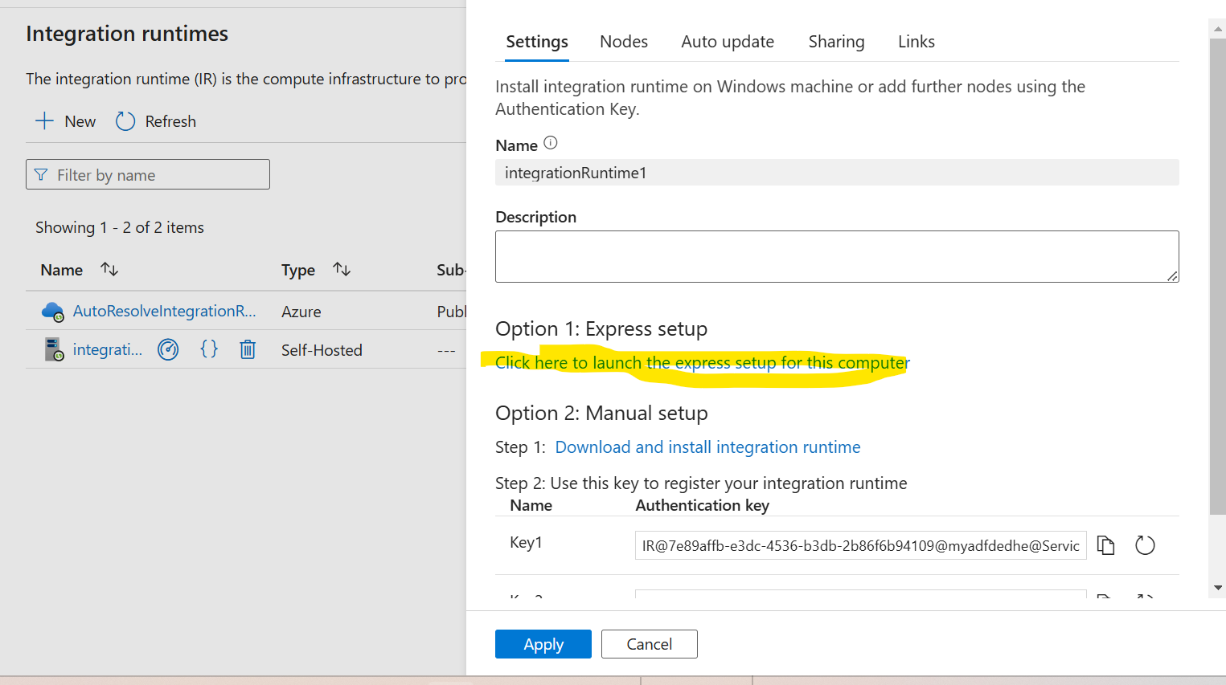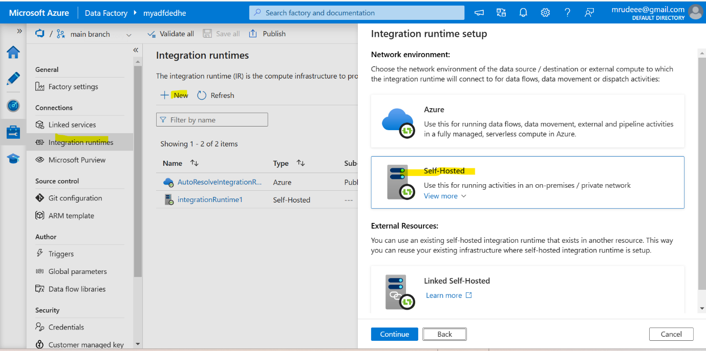In ADF, launch studio, and click on integration runtime, click on new. After that, click on self-hosted. It will create a new IR, then it will give you option to download the setup file. Download that file and copy into the VM.
3. 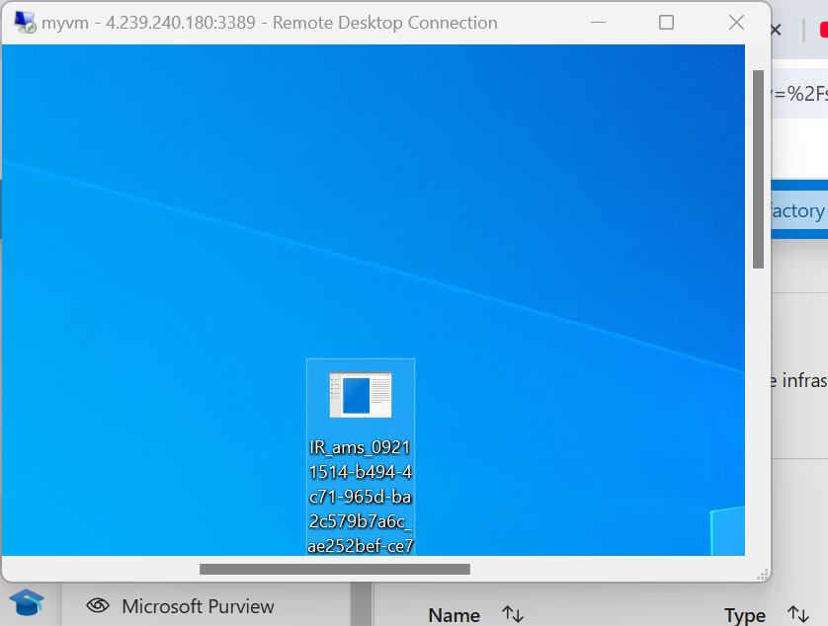Run that program and it will connect with the ADF. Also make sure in VM networking settings, access from 80,443 port is there both inbound and outbound.
4. 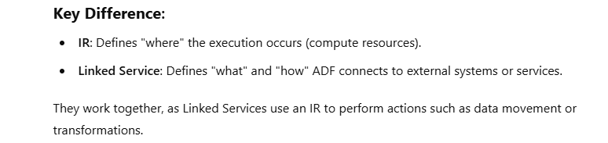Now once the IR status is running, you need to create a Linked Service with the IR. See basically IR is just a medium which is there to connect the VMs/Servers to ADF, but the linked service is where you actually use the IR to define what kind of data you would be loading.
5. We would require two IR,
   1. For VM – You can use IR created by us. The LS type – FILE SYSTEM
   2. 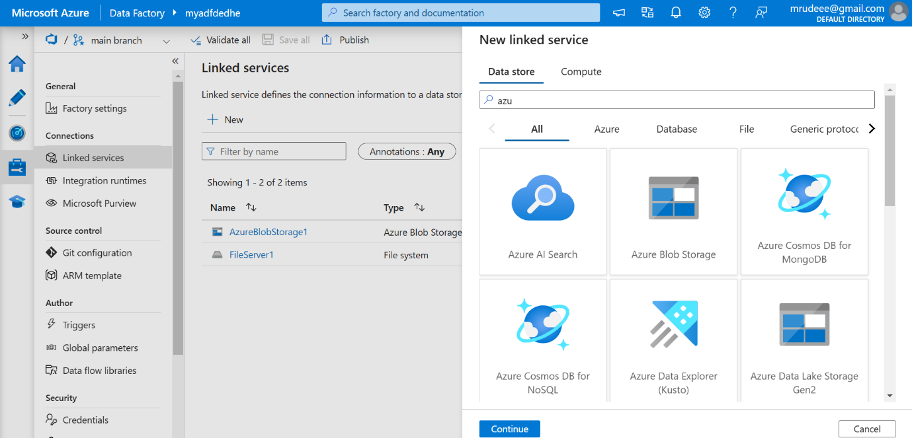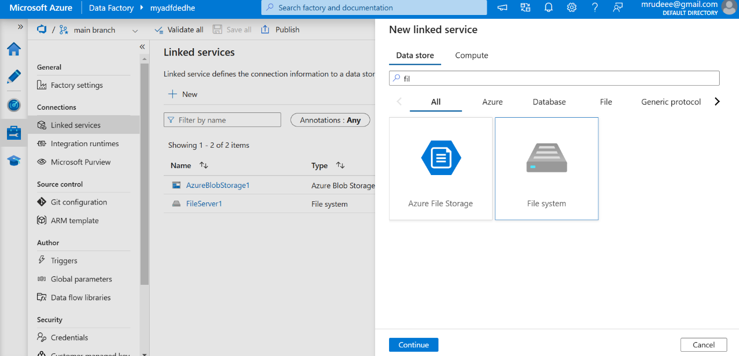For storageaccount – The default IR created by Azure to connect with azure resources. – The LS type – Azure Blob Storage
6. Most of the time while creating the File Storage connection you would get the error. So check below values to be put in the LS – file server. 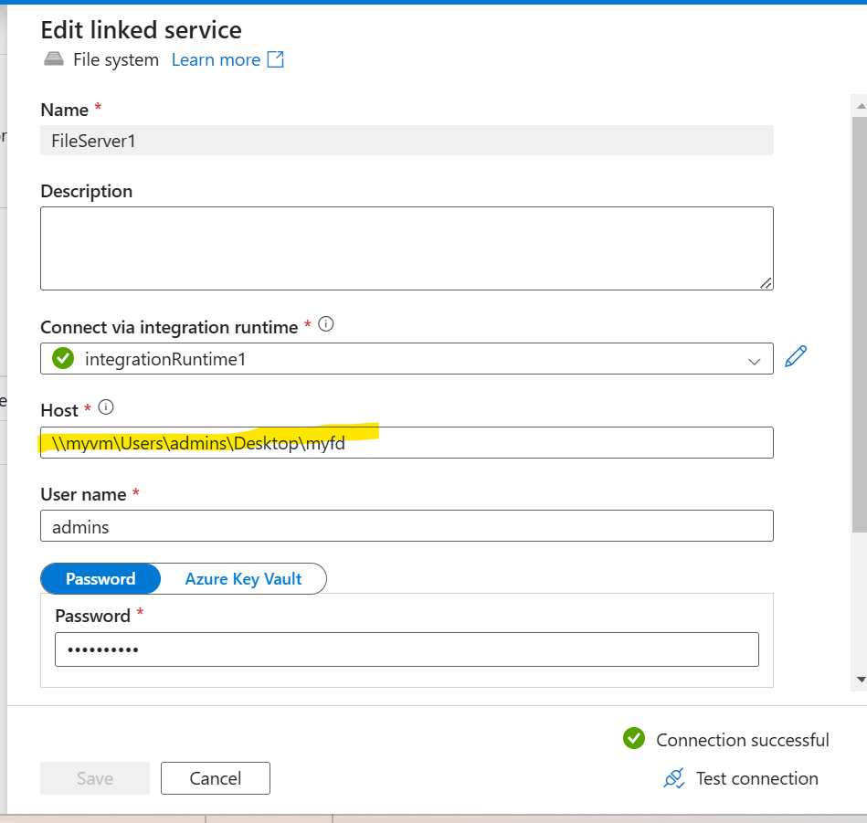
7. The highlighted path shown above is the path of the folder where you will dump the excel file. Now make sure to go in the folders properties and share it to ‘everyone’, so the ADF can access it. 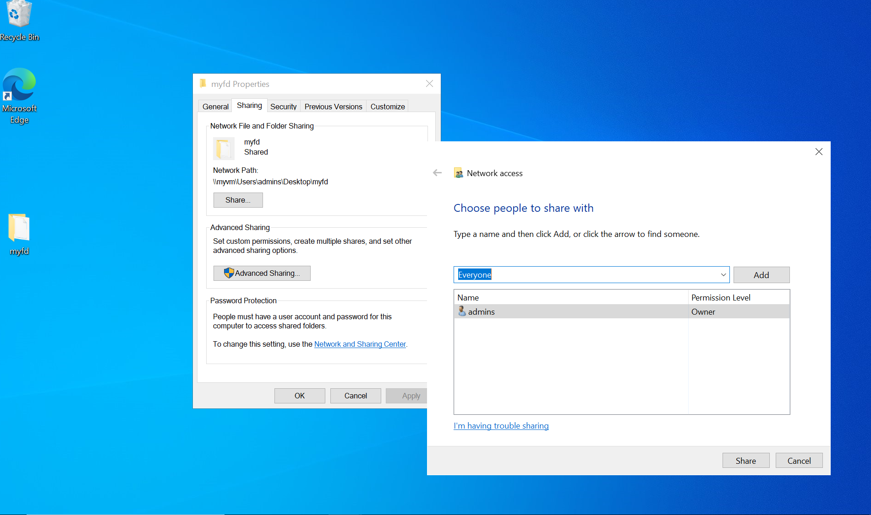
8. After that, you must run below 2 commands in the IR folder and restart the IR service (in services), because if not the Linked Service won’t be able to connect to the folder, as this is a security update from Microsoft. 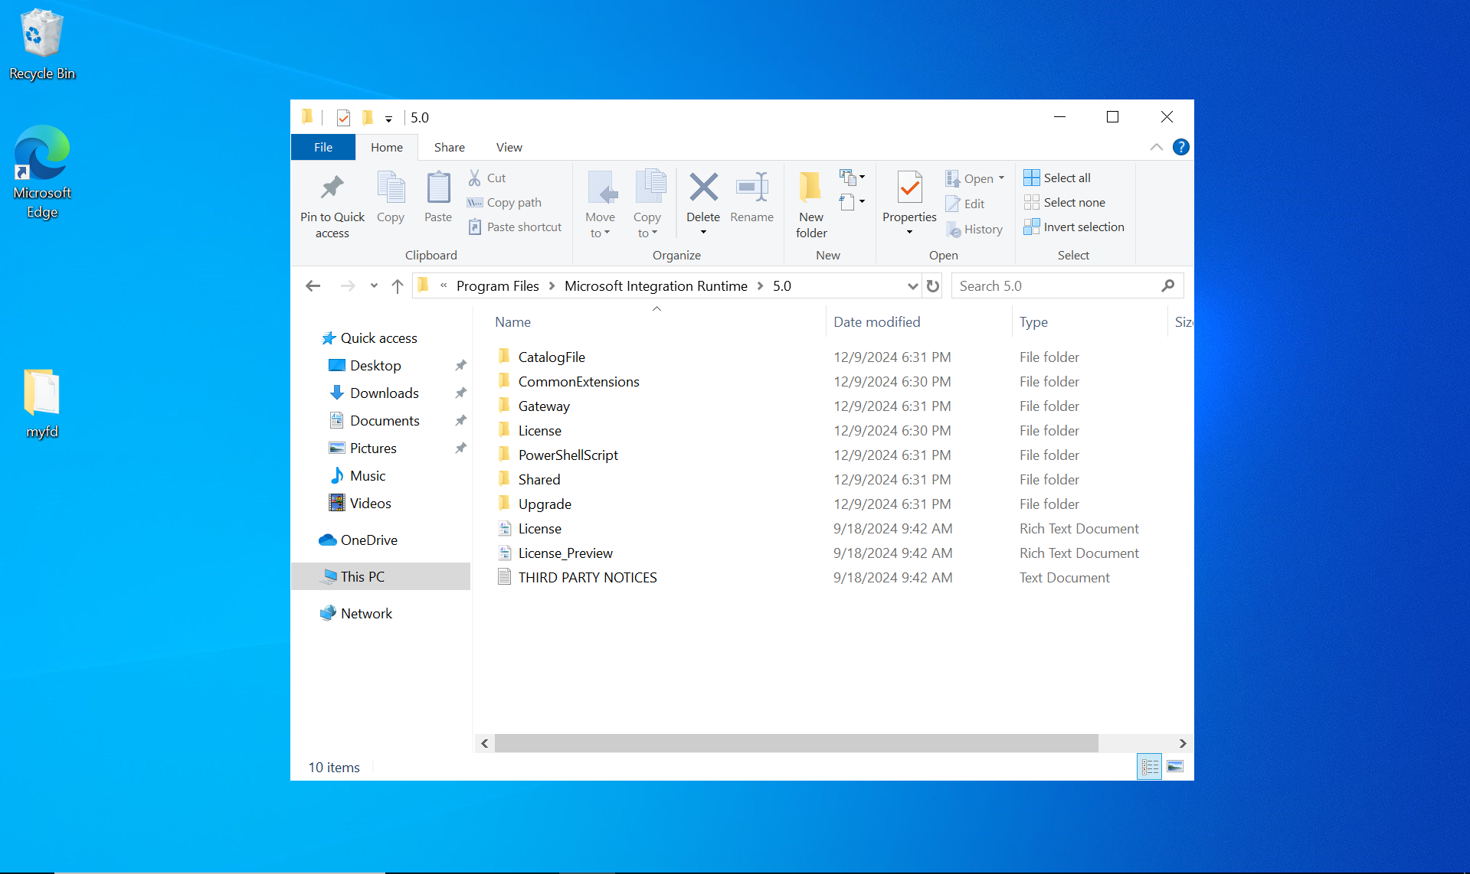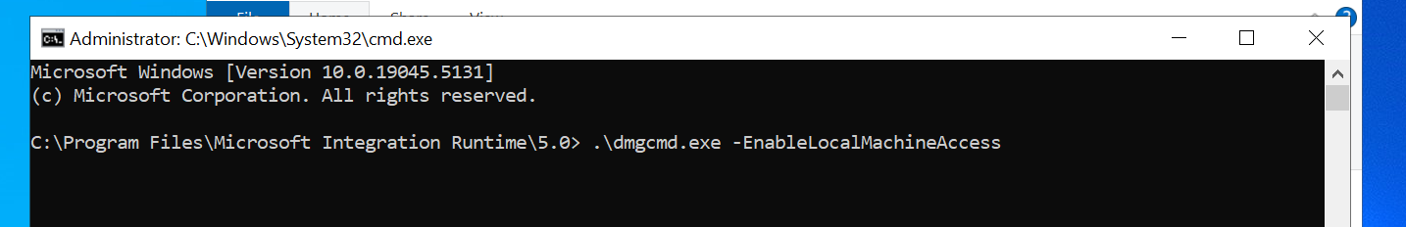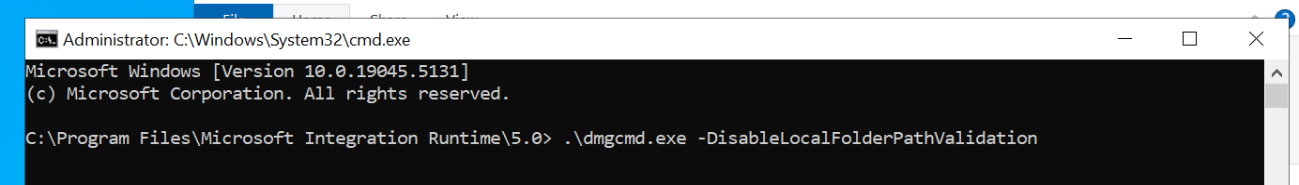
9. Once that is done, you can now create the Azure Blob Linked Service, where you use the default IR created by azure. 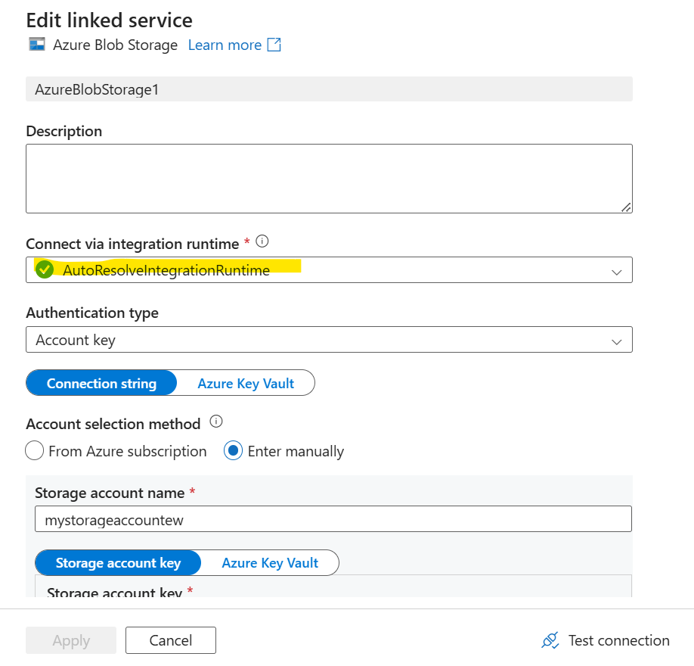
10. Now you can start creating the pipeline. In Author. In Source put the VM LS and in sink put the storageaccount LS. Also make sure that the storageaccount container has its access level to the public and not private.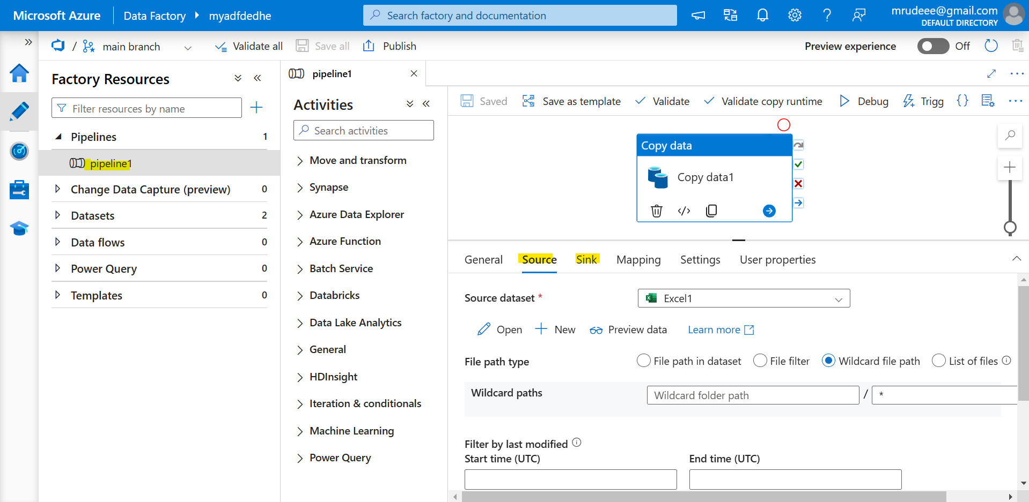 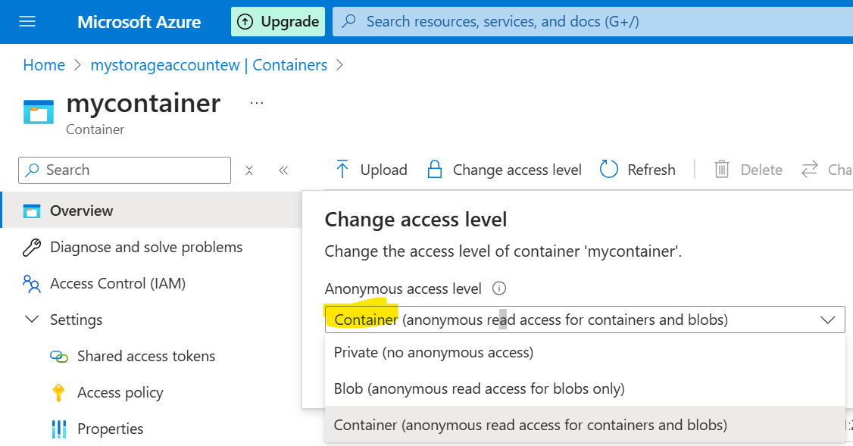
11. In mapping you can set how and which column you want to replicate or anything. 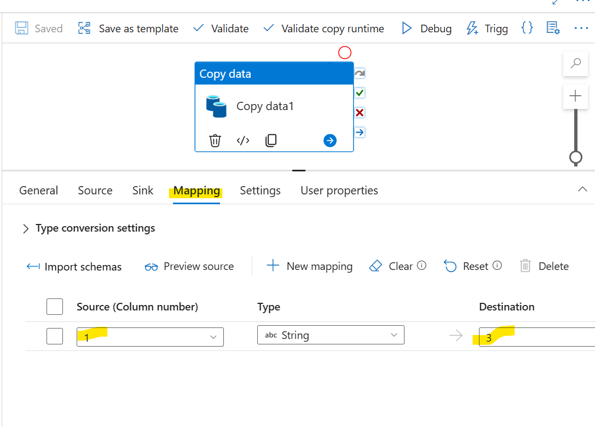
12. 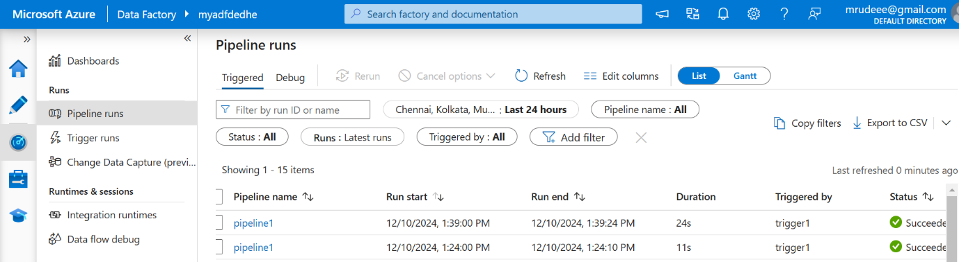 Once that is done you need to create a trigger and associate with the pipeline. After that you can run the pipeline and once it is successfully ran, you can see the file in the storage account with the data. 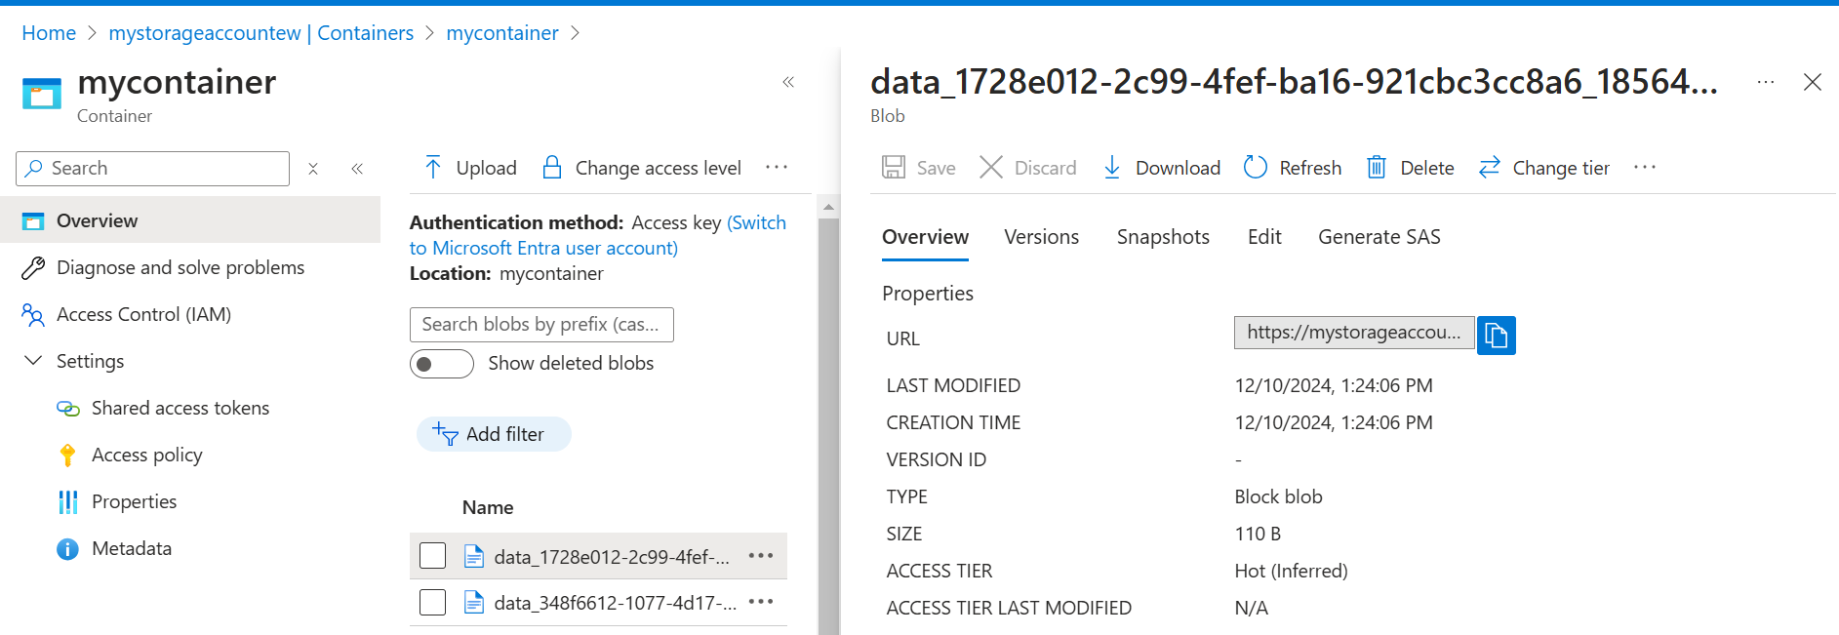
13. See the column 1 has been copied as 3 in the data. 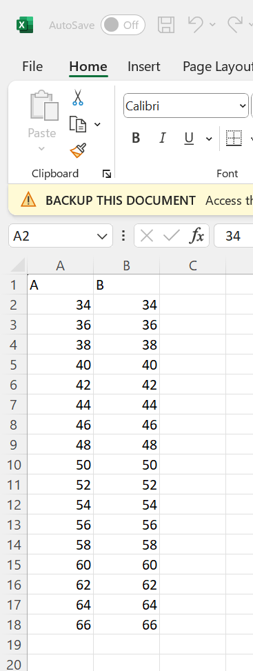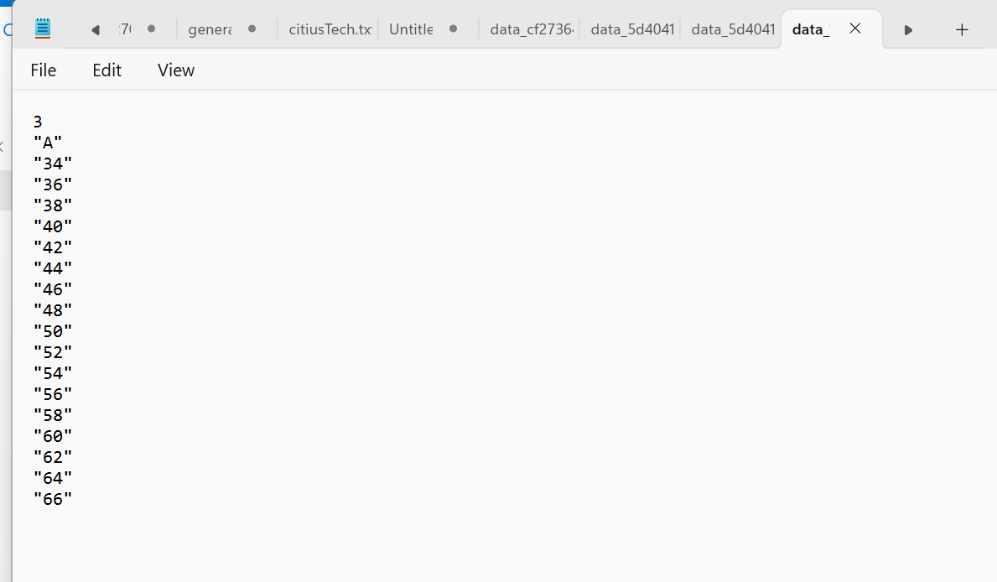
14. There are other functionalities to connect to azure functions and also to change the trigger. Even to connect with azure devops. So you can make a lot of different types of pipelines with Azure Data Factory. 